Geometry: Unit 6, Lesson 5

- A triangle with vertices $\left(2, -2\right)$, $(8, -4)$, and $(5, 4)$ is rotated $90°$ clockwise about the origin. What is an example of one of the vertices on the rotated triangle?

$(-4, -8)$, $(-2, -2)$, or $(4, -5)$

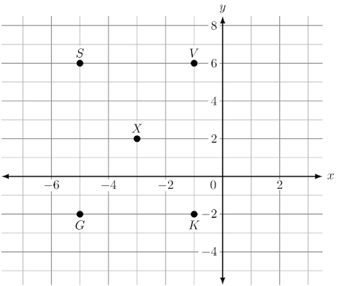
- Five points on the coordinate plane are shown. The point, $X$, located at $\left(-3, 2\right)$ is transformed according to the rule, $(x, y)→(x-2, y-4)$. Which point on the graph represents the transformed point?

Point $G$

- Point $M$ has the coordinates $(3, 8)$. What are the coordinates of point $M$’ after a rotation of $180°$ clockwise about the origin.

$$(-3, -8)$$

